## SYSTEM REQUIREMENTS AND SYSTEM ANALYSIS

### Requirement Collection

Front End Development requirements are a list of necessary functions, capabilities or characteristics related to Word Press theme and plans for creating it.

The process that was held while collecting the requirements of the system are as follows:

###### Team Discussion

Team discussion is the process of discussing how the project should be implemented by the professionals.

###### Understanding the focused group

Theme should have the aim of what the audience want t~~o~~ see in the

theme.

### System Requirements

##### Functional Requirements

Functional requirement of the system describes what the system does. The main functional requirements of this system are as follows:

* + - * User should be able to view all the necessary information and specification about this

project.

* + - * Browser compatibility.
      * Responsive to all devices.
      * Administrator (Theme Developer) can modify theme under GPL license.[1]

##### Non-Functional Requirements

A non-functional requirement describes how the system performs a certain function.

Non-functional requirements generally specify the system’s quality attributes or characteristics. These include properties such as reliability, usability, storage occupancy, performance, and response time.

### SYSTEM REQUIREMENTSPECIFICATION

* + Should describe functional and non-functional requirements so that they are understandable by system users who don’t have detailed technical knowledge.
  + User requirements are defined using natural language, tables and diagrams.

##### Software Requirement Specification

* + - Scripting Languages: html, javascript
    - Styling Language: css.
    - Server side Language: php.
    - IDE: Visualstudio, Xampp

##### Hardware Requirements Specification

* + - Processor : Intel core i3 or above
    - Hard Disk : 250GB
    - Ram : 2GB or above

### Feasibility Analysis

A feasibility study is an analysis of how successfully a project can be completed, accounting

for factors that affect it such as economic, technological, legal, and scheduling factors. Project manager use feasibility studies to determine potential positive and negative outcomes of a project investing a considerable amount of time and money into it.

Feasibility studies allow companies to determine and organize all of the necessary details to make business work. A feasibility study helps to identify logistical problems, and nearly all business-related problems, along with the solutions to alleviate them.

Feasibility studies can also lead to the development of marketing strategies that convince investors or a bank that investing in the business is a wise choice.

##### Economic Feasibility

Economically, the theme of our work bound to do well. There is little cost associated for using the system. Hence, the system is economically feasible. If owner needs any supports on this theme then they will be available upon Email Request.

##### Operational Feasibility

Operational feasibility asks if the system will work when developed and installed. The system is user friendly so the user can use this system more enthusiastically. The following points were taken into account for operational feasibility of the system:

* + - * The system causes no harm.
      * The theme is affordable and has low operational cost.

##### Technical Feasibility

The website must be evaluated from the technical aspect first. The valuation of this feasibility must be based on an outline design of the website requirement having identified an outline system, the investigation must go on to suggest the type of equipment, required method developing the system, of running the system once it has been designed. Technical issues raised during the investigation are:

* + - * Does the necessary technology exist to do what is suggested/assigned?
      * Can the system be upgraded if developed?

The theme was designed and developed such that the necessary functions and performances can be achieved using customization. Therefore, the project is feasible and may still be used even with the newer version of same software supporting older versions.

##### Schedule Feasibility

Schedule feasibility is a measure of how reasonable the project timetable is. So, feasible schedule had been managed through proper time schedule.

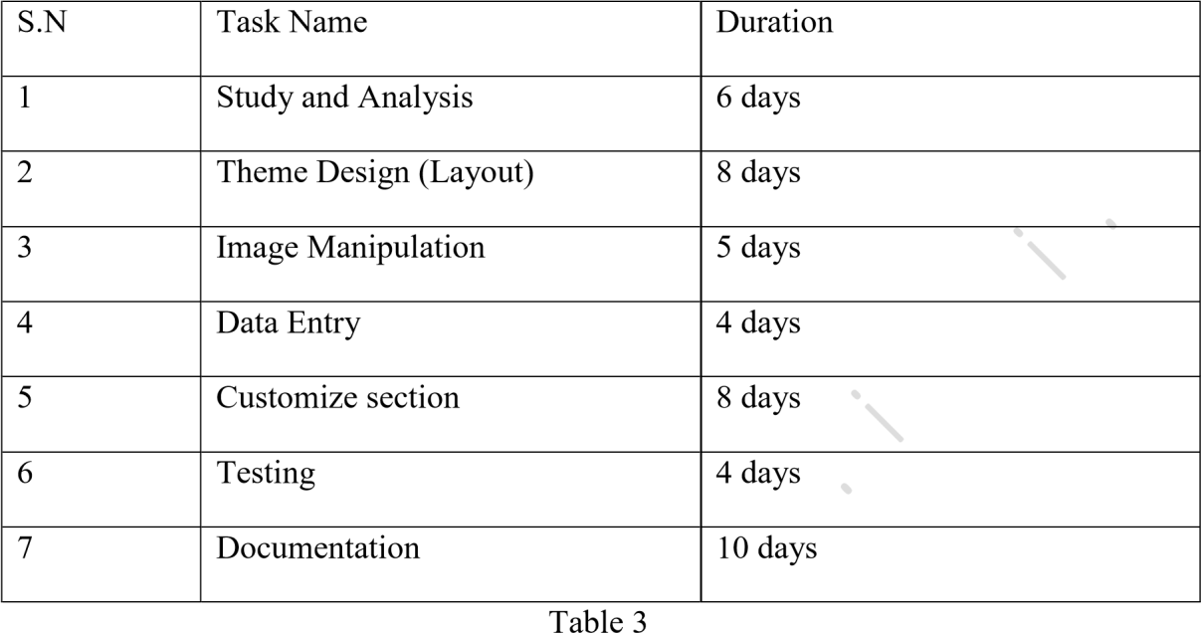

**Fig**  Schedule Feasibility Table

##### About the website

##### VentureIntoADV is a travel booking website which involves looking for places, checking out optimal prices for packages to visit places and booking for the same.

##### We have sections that enlighten the visitor with the culture, history and information about many places around the globe. We have sections that help the visitor understand popular places that people like to visit so that the viewer isn’t burdened by the confusion of choices. This implies that VentureIntoADV is not just a website that helps with booking but its basic motive is to make the visitor’s job easier.

##### Once the visitor is able to decide which package they are interested in they will be taken to the contact and payments sections, where they can easily book the trip of their choice and leave the page.

## SYSTEM DESIGN

### Theme Design Layout

The theme used for our project is trending theme which have good layout format. The theme was developed on our own referring some of

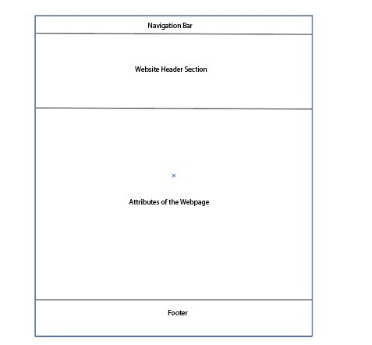

**Fig** : Layout of Theme Design

###### Navigation Bar

Navigation bar is the place where users can go through all the items that are selected from website back-end. Actually, it is a page type of the site. We can create menus .This will bring to the edit menus screen which is divided into two columns. The column on our left has our pages, categories, and custom links tab. The column on the right is where we can add and adjust menuitems.

###### Website Header Section

###### A website header is the top section of the web page. Back in the day, people understood headers as narrow strips in the top parts of the websites that contained a logo, a call to action, and contact information. But in modern design, the whole space above the fold of the homepage is considered a header.

###### Sidebar

Sidebar is the section where recently viewed products, search filter etc. are placed as a shortcut for the content of the site especially for product shop pages. themes to display information that is not a part of the main content. It is not always a vertical column on the side. It can be a horizontal rectangle

below or above the content area, footer, header, or anywhere in the file.

###### Footer

The footer area of a website is usually defined in the template file footer.html. In some themes, the area may also contain a widgetized area with multiple columns that you canuse.

## TESTING

### Introduction To Testing

###### Unit Testing:

Unit testing focuses verification effort on the smallest unit of software design that is the module.

Using procedural design description as a guide, important control paths are tested to uncover errors within the boundaries of the module. The unit test is normally white box testing oriented

and the step can be conducted in parallel for multiple modules.

###### Validation Testing:

At the end of integration testing software is completely assembled as a package. Validation testing is the next stage, which can be defined as successful when the software functions in the

manner reasonably expected by the customer. Reasonable expectations are those defined in the

software requirements specifications. Information contained in those sections form a basis for validation testing approach.

###### Integration Testing:

Integration testing is a systematic technique for constructing the program structure, while conducting test to uncover errors associated with the interface. The objective is to take unit tested methods and build a program structure that has been dictated by design.

### Browser Compatibility Testing

Browser compatibility test is the test done to ensure that site runs on all browsers

i.e. chrome, safari etc. these browsers run on different platforms so it is very important ensure that the theme is all platform friendly.

|  |  |  |  |  |  |
| --- | --- | --- | --- | --- | --- |
| S.N | Test Case | Test Browser | Expected Result | Actual Result | Remarks |
| 1 | C1 | Google Chrome | Successful | Successful | Pass |
| 2 | C2 | Opera Mini | Successful | Successful | Pass |
| 3 | C3 | Safari | Successful | Successful | Pass |
| 4 | C4 | Mozilla Firefox | Successful | Successful | Pass |

Browser Compatibility Testing Table

### Responsive Testing

Responsive testing is very important because theme should give majority of the users as they open the site throughout the various devices like laptop, mobiles,

tablets etc.

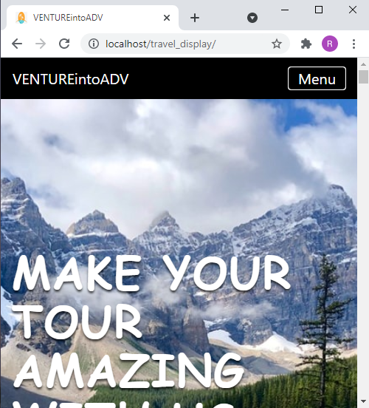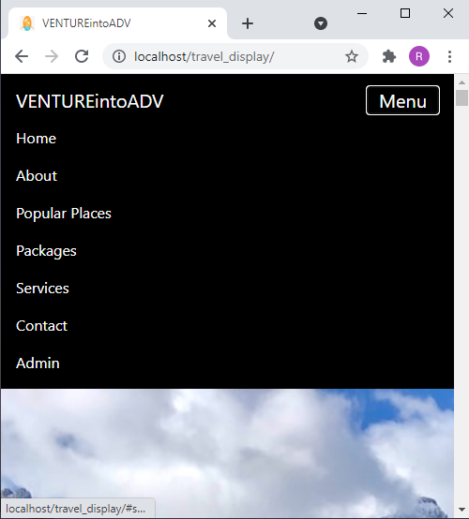

**Fig** : Responsive Navigation bar

Fu

# IMPLEMENTATION

**Implementation Tools**

Implementation is an activity that is contained throughout the development phase. It is the process of bringing designed system into operational use. The system is tested first and then turned into working system. Every task identified in the design specification is carried out in this phase.

# Front End Tools

### HTML

HTML known as Hyper Text Mark-up Language, the authoring language used to create documents on the World Wide Web. HTML defines the structure and layout of a Web document by using a variety of tags and attributes. Theme or plugin does exactly what you need it to do, and looks almost exactly how you need it to look. But still, you wish it would look slightly different. For this reason, HTML was used. HTML tags were used in posts, pages, sidebar text widgets to code a hyperlink by hand, or adjust the header sizes.

### CSS

CSS stands for Cascading Style Sheets. It describes how HTML elements are to be displayed on screen or in other media. In this project, additional CSS was used when further customization on the site was required. Sometimes, the theme does not work as per the requirement of the user so to meet the requirement of the user additional CSS was used. To add in the icons, to scale the logo properly, change the font size of the specified content, to add a specific callout box, or style just a section of a post differently CSS was used. The theme option does provide certain features but to add the features according to the client’s requirement additional CSS was applied.

### JAVASCRIPT

JavaScript (sometimes abbreviated JS) is a prototype-based scripting language that is dynamic, weakly typed. JavaScript is a client-side scripting language meaning that JavaScript code is written into an HTML page. When a user requests an HTML page with JavaScript in it, the script is sent to the browser and it's up to the browser to do something with it. It is used to make webpage more interactive, check or modify the contents of forms, change images, open new windows and write dynamic page content.

### BOOTSTRAP

Bootstrap is a [free and open-source](https://en.wikipedia.org/wiki/Free_and_open-source) [CSS frame work](https://en.wikipedia.org/wiki/CSS_framework) directed at responsive, [mobile-first](https://en.wikipedia.org/wiki/Responsive_web_design#Mobile_first%2C_unobtrusive_JavaScript%2C_and_progressive_enhancement) [front-end web development.](https://en.wikipedia.org/wiki/Front-end_web_development) It contains [CSS](https://en.wikipedia.org/wiki/CSS)- and (optionally) [JavaScript](https://en.wikipedia.org/wiki/JavaScript)-based design templates for [typography,](https://en.wikipedia.org/wiki/Web_design#Typography) [forms,](https://en.wikipedia.org/wiki/Form_(HTML)) [buttons](https://en.wikipedia.org/wiki/Button_(computing)#HTML), [navigation,](https://en.wikipedia.org/wiki/Web_navigation#Local_website_navigation) and other interface components. Bootstrap is a web framework that focuses on simplifying the development of informative web pages (as opposed to [web apps](https://en.wikipedia.org/wiki/Web_Apps)). The primary purpose of adding it to a web project is to apply Bootstrap's choices of color, size, font and layout to that project. As such, the primary factor is whether the developers in charge find those choices to their liking. Once added to a project, Bootstrap provides basic style definitions for all [HTML elements](https://en.wikipedia.org/wiki/HTML_element). In addition, developers can take advantage of CSS classes defined in Bootstrap to further customize the appearance of their contents. For example, Bootstrap has provisioned for light- and dark- colored tables, page headings, more prominent pull quotes, and text with a highlight.

# Back End Tools

### XAMPP

XAMPP is a free and ope[n-source](https://en.wikipedia.org/wiki/Free_and_open-source) [cross-platform](https://en.wikipedia.org/wiki/Cross-platform) [web server](https://en.wikipedia.org/wiki/Web_server) [solution stack](https://en.wikipedia.org/wiki/Solution_stack) package developed by Apache Friends, consisting mainly of the [Apache HTTP](https://en.wikipedia.org/wiki/Apache_HTTP_Server) [Server](https://en.wikipedia.org/wiki/Apache_HTTP_Server)[,](https://en.wikipedia.org/wiki/MariaDB) [MariaDB](https://en.wikipedia.org/wiki/MariaDB) [database,](https://en.wikipedia.org/wiki/Database) and [interpreters](https://en.wikipedia.org/wiki/Interpreter_(computing)) for scripts written in the [PHP](https://en.wikipedia.org/wiki/PHP) and [Perl](https://en.wikipedia.org/wiki/Perl) [programming languages.](https://en.wikipedia.org/wiki/Programming_language) Since most actual web server deployments use the same components as XAMPP, it makes transitioning from a local test server to a live server possible. XAMPP's ease of deployment means a [WAMP](https://en.wikipedia.org/wiki/WAMP) or [LAMP](https://en.wikipedia.org/wiki/LAMP_(software_bundle)) stack can be installed quickly and simply on an operating system by a developer, with the advantage a number of common add-in applications such as [Word Press](https://en.wikipedia.org/wiki/Wordpress) and [Joomla!](https://en.wikipedia.org/wiki/Joomla!) can also be installed with similar ease using [Bitnami](https://en.wikipedia.org/wiki/Bitnami) .

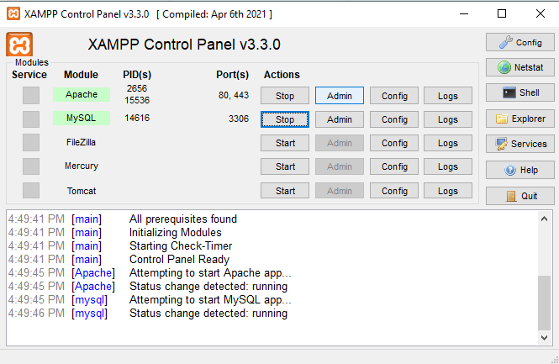

**Fig** : XAMPP Control Panel

### PHP

PHP is an amazing and popular language. It is powerful enough to be at the core of the biggest blogging system on the web. PHP is an acronym for "PHP: Hypertext Pre-processor". PHP is a widely-used, open source scripting language. PHP scripts are executed on the server. PHP is free to download and use.

PHP files can contain text, HTML, CSS, JavaScript, and PHP code. PHP code are executed on the server, and the result is returned to the browser as plain HTML. PHP files have extension “.php".

### SCREEN SHOTS OF OURWEBSITE:

**FRONT END:**

**NAVIGATION BAR:**



**Fig** Navigation Bar

### FOOTER:

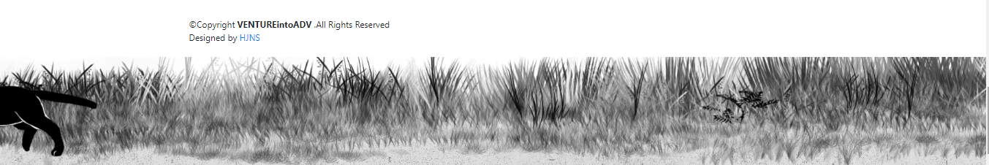

**Fig** : Footer

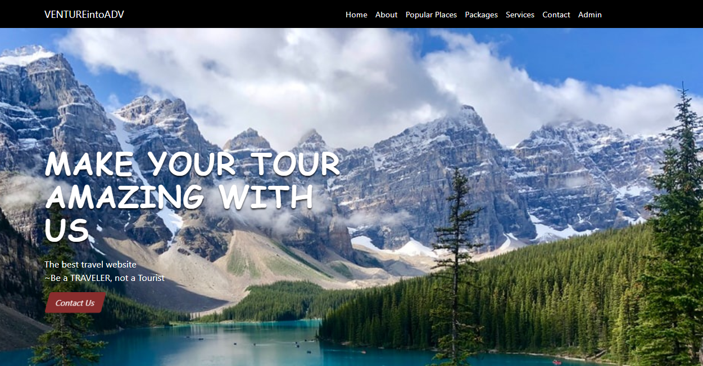

**Fig**  Home Page

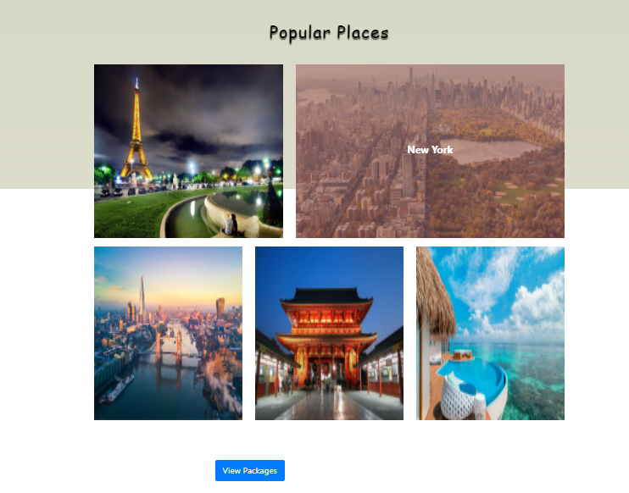

**Fig** Popular places

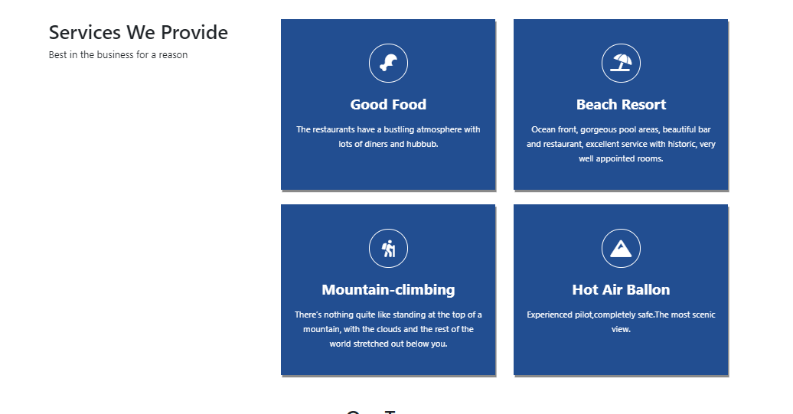

**Fig** Services we provide



**Fig** Our team

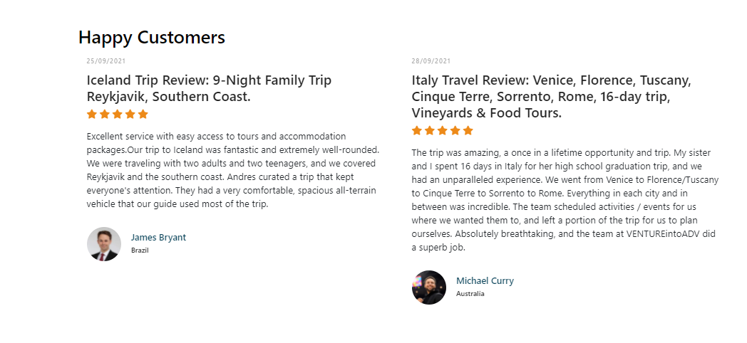**Fig**  Reviews

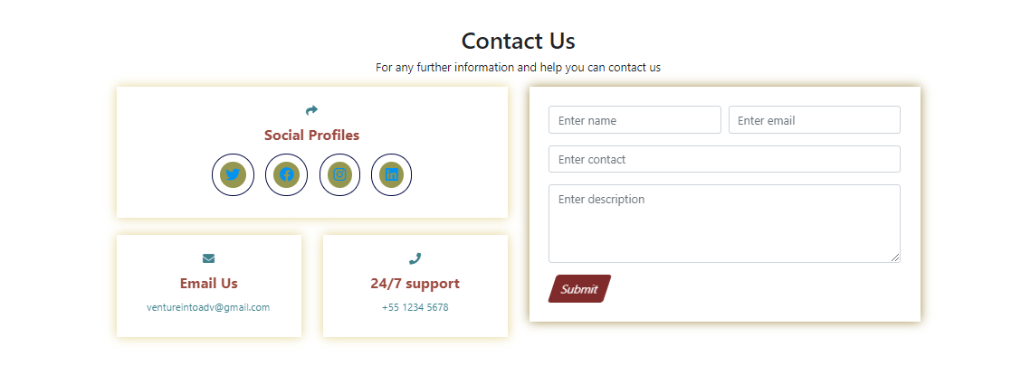

**Fig** Contact Us

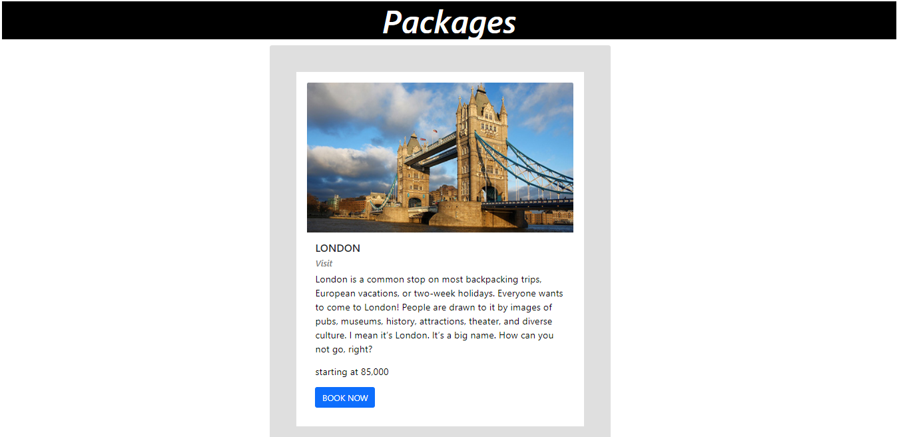

**Fig**  Packages

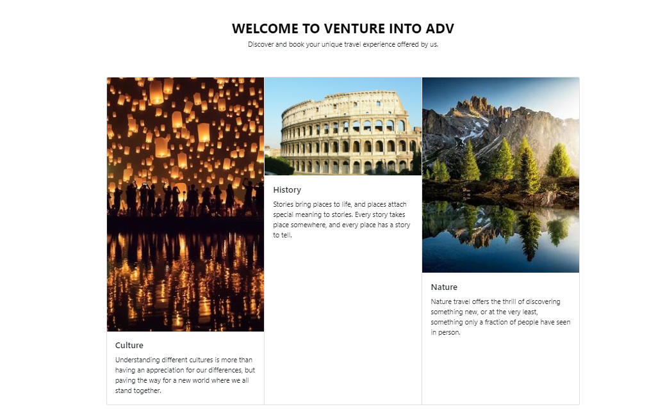

**Fig** : About

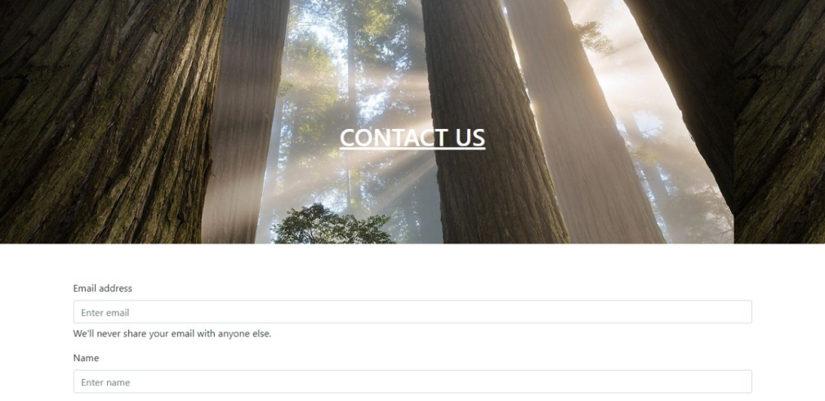

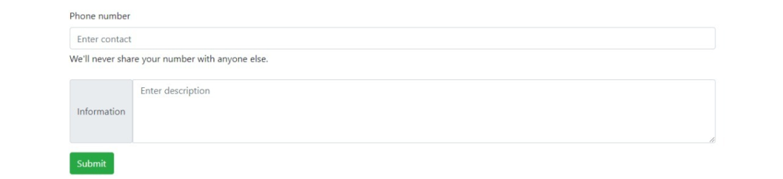

**Fig** : Contact form

# Admin Section

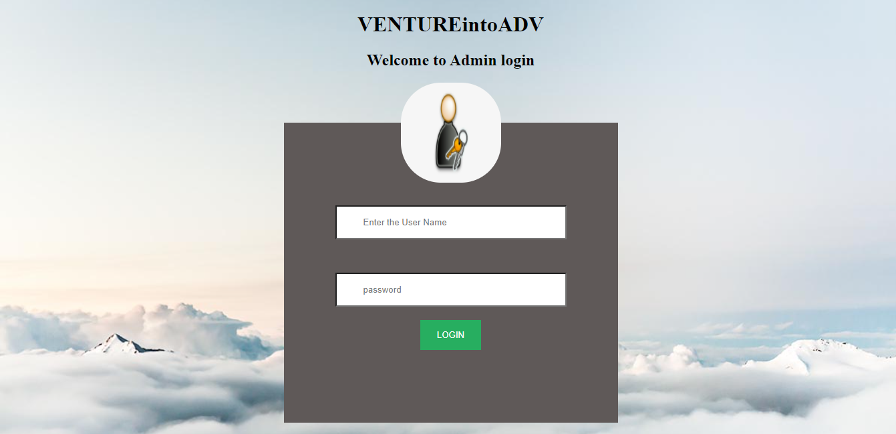

**Fig**  Admin Log In

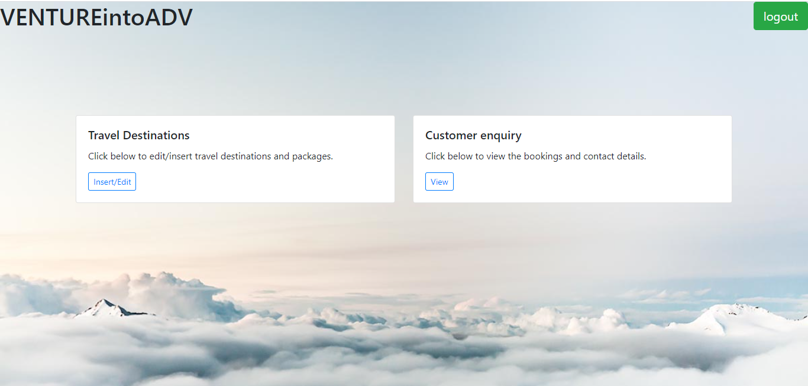

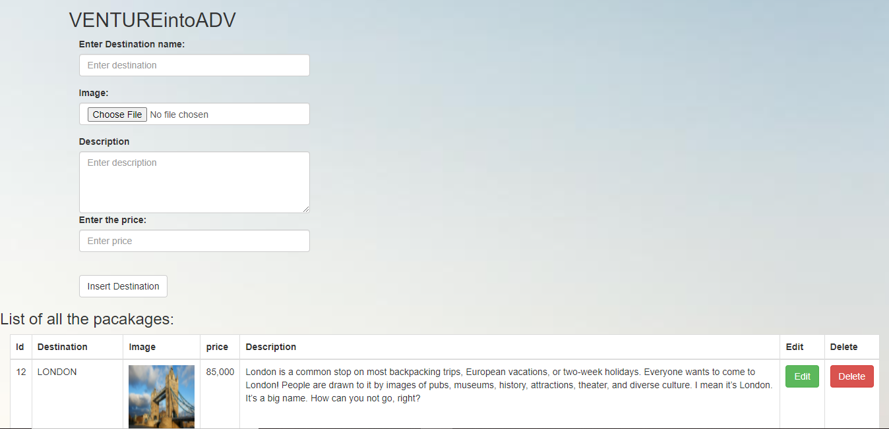

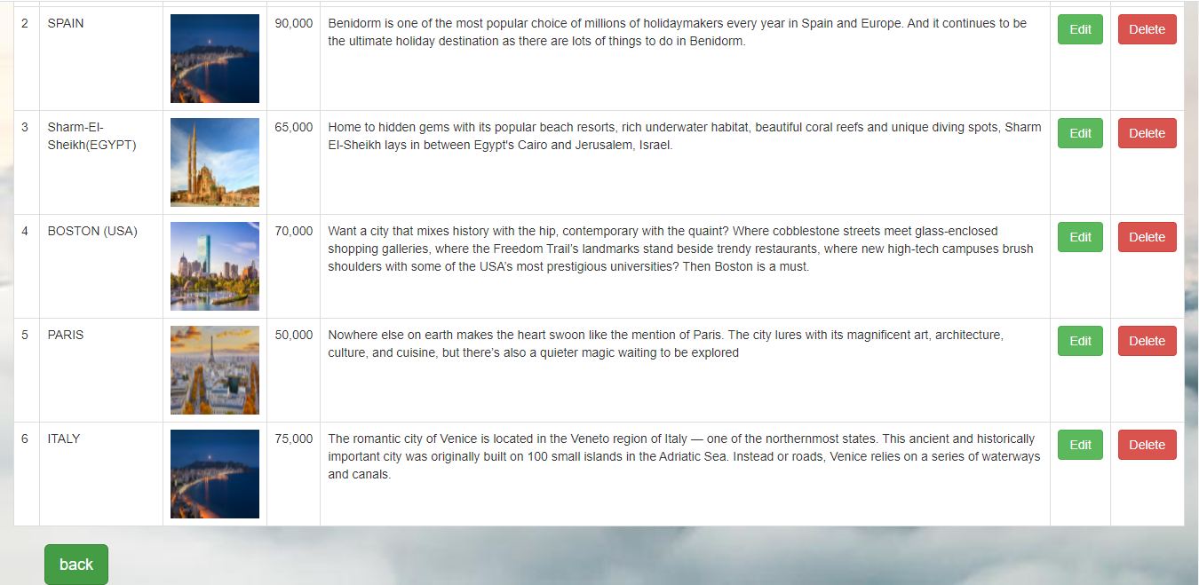

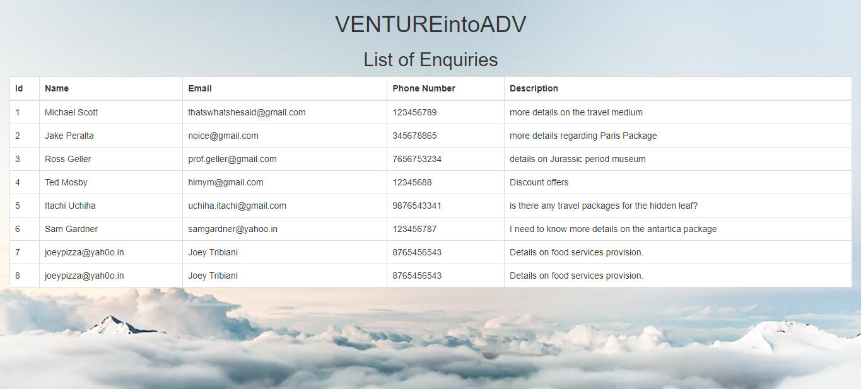

**Fig**  After Admin Log In

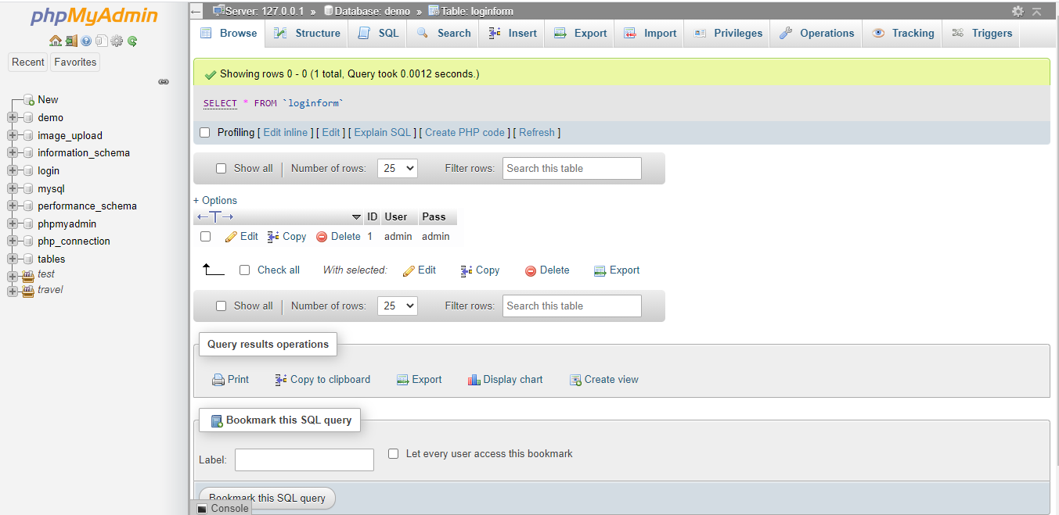

**Fig** : Admin Log In database

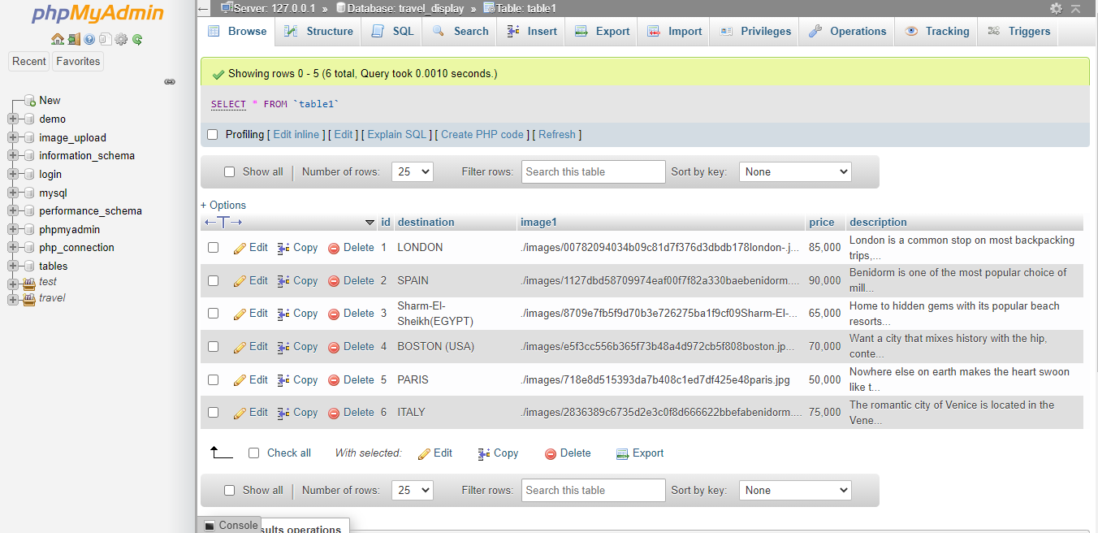

**Fig**  Package database

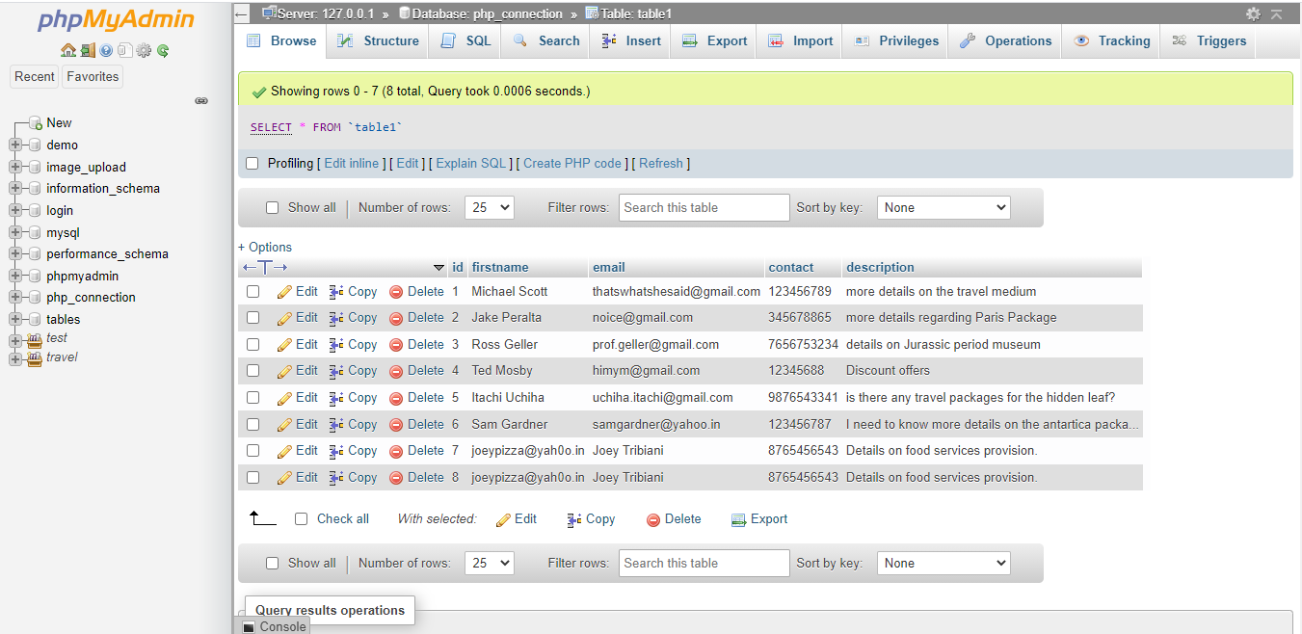

**Fig 16.5**: Contact us